H-1B JD Explanation
What follows below is a detailed description of the job duties of the Associate, Risk Management position we offer to Mr. Liu at Bank of China’s New York Branch (“BOC-NY”). They reflect not only the specialized and complex nature of the position, but also demonstrate that its professional responsibilities require the body of specialized professional knowledge in data analysis, statistical modeling, finance and economics, etc. that is normally taught by courses taken in these master-level university science degree programs.

- Liquidity Oversight and Exposure Monitoring (Percentage of time spent: 30%)
This requires the employee to have thorough academic understanding of database system structure, plus a specialized theoretical knowledge of data visualization and storytelling with data necessary to perform such duties. The employee is required to review, monitor and analyze the Bank’s Risk Data to ensure data mapping and collection process is valid and data elements have been reconciled across systems, data attributes are in compliance with Fed instructions and liquidity risk exposures align with the risk appetite. The results of this complex review process will affect the Bank’s regulatory report directly.
Such work requires the employee to analyze and validate data of the Bank’s liquidity portfolio from multiple database system, build up methodology to perform statistical oriented risk analysis to identify, monitor and track liquidity position and risk exposure and predict future trends. The employee must be able to analyze and assess the Bank’s funding structure, risk profile, complexity and activities to provide insight and commentary on the liquidity risk management. The employee must be able to analyze risk data intelligently and use it to build the quantitative methodologies required to derive the exposure of the liquidity portfolio.
The analysis process typically requires skills from spreadsheet analysis to application of advanced techniques such as VBA, SQL and Bloomberg. Because the employee will be exposed to a large amount of financial data, specialized quantitative knowledge in statistics and data analytics is required to perform these complex and sophisticated analytical responsivities. Based on the results the employee derived, he is required to formulate a dashboard to address the Bank’s liquidity portfolio risk status.
A sample of the analysis Mr. Liu has done is attached here for your reference. (FR2052a Liquidity Reporting Dashboard)
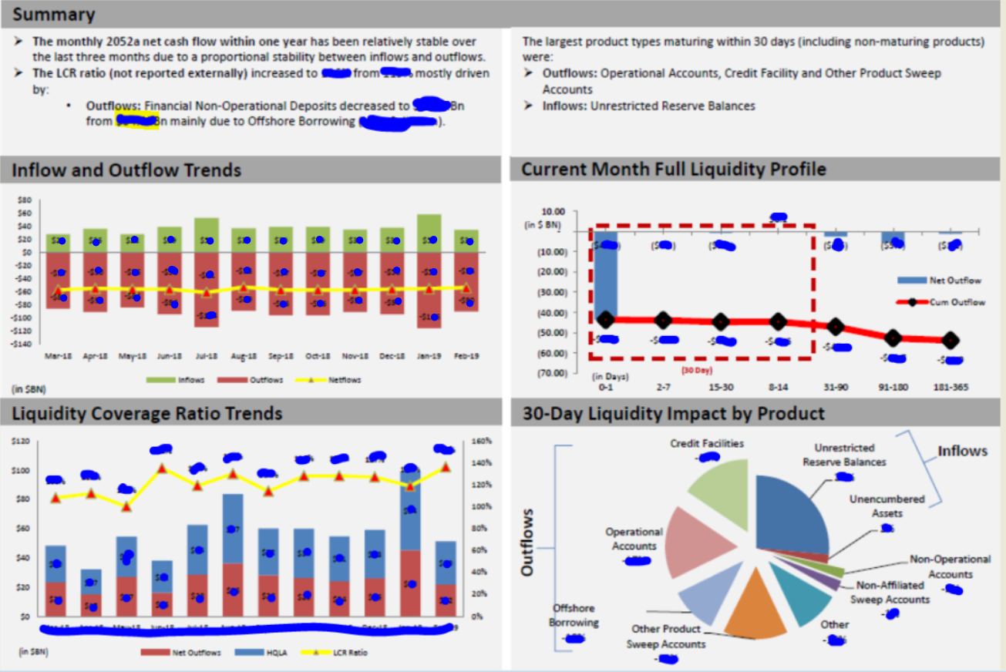
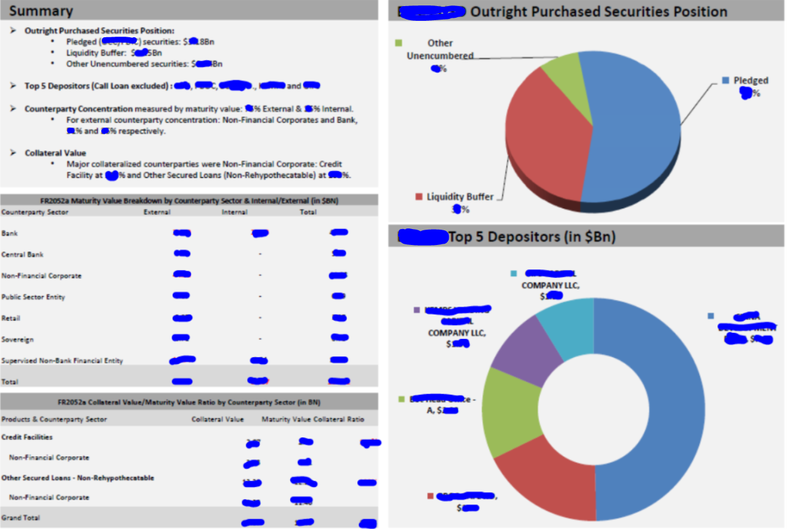
The analysis was performed on the Bank’s liquidity report including FR2052a, Liquidity Stress Testing and Cash Flow Projection etc. Mr. Liu analyzed the cash flows, funding structure, risk profile and product complexity with a focus on the potential impact on the liquidity position and exposures. The analysis has been included in the CRO monthly report package and presented to the Bank senior management to provide insight and commentary on the risk management. (Customer name and sensitive information was replaced/covered for confidentiality purpose).
In Mr. Liu’s case, the graduate level courses he took in Applied Analytics Framework and Methods and Modern Database Architecture and Data Visualization and Design at Columbia University provided him with the theoretical academic preparation required to perform these sophisticated responsibilities.

- Liquidity Behavior Modeling (Percentage of time spent: 20%)
This requires the employee to have thorough academic understanding of statistical regression and time series analysis, plus a specialized theoretical knowledge of data analytic framework and methods necessary to perform such duties. The employee is required to establish cash segmentation model and perform customer behavior analysis to enhance the Bank’s asset and liability management to forecast the future liquidity positions and funding structures. The results of this complex analysis and modeling process will enhance the Bank’s strategic plan and risk management directly.
Such work requires the employee to analyze and model customer behavior by various statistic approaches including volatility analysis, linear/logistic regression model, time series model and replicating portfolio etc. The employee must be able to analyze and assess the Bank’s current deposit operational level, runoff and sedimentation, term deposit rollover and early remediation behaviors, loan prepayment and off-balance-sheet facilities contingent withdraw risk based on internal historical data, market dynamic data and industry benchmark.
The modeling process typically requires skills from time series analysis to application of regression models such as ARIMA and logistic regression. Because the employee will need to build internal model based on historical data and industry modeling practices, specialized quantitative knowledge in statistics and data analytics is required to perform these complex and sophisticated model responsivities. Based on the results the employee derived, he is required to formulate a dashboard to address the Bank’s liquidity portfolio risk status.
In Mr. Liu’s case, the graduate level courses he took in Applied Analytics Framework and Methods, Research Design and Analytics and Leading Change at Columbia University provided him with the theoretical academic preparation required to perform these sophisticated responsibilities.

- Enhance Liquidity Risk Management Practices - Liquidity Stress Testing Model Validation and Cash Flow Projection Report Review (Percentage of time spent: 20%)
This requires the employee to have thorough academic understanding of scenario analysis and stress testing, plus a specialized theoretical knowledge of financial model design necessary to perform such duties. The employee is required to validate, analyze and provide recommendations on the Bank’s Liquidity Stress Testing model to ensure the model is valid and fit-for-purpose, stress scenarios are sufficient and in compliance with EPS requirement, and various assumptions are conceptually sound and consistent across scenarios, products/accounts and planning horizon. The results of this complex review process will affect the Branch’s safety and soundness liquidity risk management practice directly.
Such work requires the employee to reconcile model data input from different database and system, review and analyze model scenarios and assumptions and validate the model performance by industry benchmarks. The employee must be able to measure and assess impact assumption of severe scenarios on the Bank’s liquidity position to identify sources of potential liquidity strain, ensure liquidity risk exposures remain in accordance with the established risk appetite and analyze any possible impact of future stresses on cash flows, liquidity position, profitability and solvency.
The model validation process typically requires skills from balance-sheet analysis to application of financial model design. Because the employee will be exposed to a large amount of financial data, specialized quantitative knowledge in statistics and data analytics is required to perform these complex and sophisticated analytical responsivities. Based on the validation results the employee reviewed, he is required to formulated recommendations to enhance the Bank’s liquidity management practices.
In Mr. Liu’s case, the graduate level courses he took in Security Analysis and Strategic and Analytics at Columbia University provided him with the theoretical academic preparation required to perform these sophisticated responsibilities.

- Liquidity Risk Report Review - Cash Flow Projection (Percentage of time spent: 10%)
This requires the employee to have thorough academic understanding of financial projection and forecast methodologies, plus a specialized theoretical knowledge of statistical approach of analysis and data modeling approach necessary to perform such duties. The employee is required to review, analyze and enhance the Bank’s Cash Flow Projection framework to ensure the rational and approach of the assumption to support the cash flow projection is reasonable, forecast assumption is consisted across products, services and key clients and recommend methodologies to enhance the projection accuracy. The results of this complex review process will affect the Branch’s s safely and soundness liquidity management practice directly.
Such work requires the employee to review the contractual cash flow projection arising from maturities, intercompany transactions, new business funding renewals and customer options. The employee needs to analyze and validate assumptions regarding the future behaviors of assets, liability and off-balance exposures. In addition, the employee is responsible for identifies and quantifies discrete and cumulative cash-flow mismatches includes sufficient detail to reflect the risk profile, complexity, currency exposures and activities. The employee must be able to analyze and assess the Bank’s data source and inputs, cash flow calculation engine including contractual and behavioral projection, liquidity funding gap to measure of the Bank’s liquidity risk exposures based on historical data analysis.
The modeling typically requires skills from balance-sheet analysis to application of analytics tools such as SQL, VBA and Bloomberg. Because the employee will be exposed to a large amount of financial data, specialized quantitative knowledge in statistics and data analytics is required to perform these complex and sophisticated analytical responsivities. Based on the results, the employee reviewed, he is required to formulate a review report to enhance the Bank’s liquidity management practices.
In Mr. Liu’s case, the graduate level courses he took in Corporate Finance and Strategic Communications at Columbia University provided him with the theoretical academic preparation required to perform these sophisticated responsibilities.

- Assisting in Control of Liquidity Risk (Percentage of time spent: 10%)
This requires the employee to have thorough academic understanding of financial position and risk exposure measurement and projection, plus a specialized practices experience of payments, clearing and settlement actives necessary to perform such duties. The employee is required to monitor, measure and management intraday liquidity, high liquid assets and investment collateral to ensure adequate liquidity positions to timely meet the payment demands against normal conditions and under stress scenarios. The results of this complex monitoring process will affect the Bank’s robust liquidity risk management framework directly.
Such work requires the employee to identify, assess and monitor the Bank’s source and use of liquidity, intraday settlement and payment activities, liquidity buffer composition and haircut, investment available to be pledged and (un)committed credit facilities. The employee must be able to perform statistical analysis and assess the potential funding gap to apply and utilize Net Debit Cap from Fed based on intraday liquidity inflow and outflow trends and seasonality patterns.
The assess and monitor process typically requires skills from data analysis to application of probability concepts such as skewness, kurtoses and confidence interval of assumed financial data distributions. Because the employee will be exposed to a large amount of transactional data, specialized quantitative knowledge in probability and statistical analytics is required to perform these complex and sophisticated analytical responsivities. Based on the monitor results, the employee assessed, he is required to formulated recommendations to enhance the Bank’s liquidity management practices.
In Mr. Liu’s case, the graduate level courses he took in Applied Analytics Frameworks and Methods and Applied Analytics in the Organizational Context at Columbia University provided him with the theoretical academic preparation required to perform these sophisticated responsibilities.

- Implement liquidity risk management regulatory projects and maintain related policy, procedures and governance (Percentage of time spent: 20%)

The employee is required to implement and execute liquidity risk management regulatory projects. In addition, the employee also need to develop and improve the policies procedures on liquidity risk management and implement the requirement of the Bank’s risk governance framework to improve the Bank’s asset liability and funding management.
This duty requires effective communication with outside regulators such as Fed or OCC with regard to any particular aspects of the Bank’s market and liquidity risk management. This duty is performed under the direct and close supervision of the department head. The employee needs to have strong business knowledge and analytical skills to fully understand the issue or subject. It also requires the beneficiary to have good communication skills to put across the main points and interact well with outside officers. Besides the above qualifications that Mr. Liu possesses, he also has the knowledge in compliance and risk management which has a great pertinence to the risk business.
Such work requires the employee to work with first line units to standardize and deliver the risk information to fulfill regulatory related projects. This also requires the employee to take a role in annual review of policies and procedures owned by Market Risk Management Department. The annual review includes past year limit performance analysis, compliance analysis, complement analysis and add-value analysis. The beneficiary should have clear understanding and sensitiveness towards changes from regulator’s action and Head Office’s authorization, investigate historical data in previous years for recommendation to this year, and straighten out the logic of the policies or procedures. The beneficiary needs to have strong applied analytics background to fully understand the department structure and operation. Mr. Liu completed his Master’s Degree in Applied Analytics, which helps him to comprehend the overview of risk management and theoretical application. He has deep research at the market risk transmutation.

In Mr. Liu’s case, the graduate level courses he took in Strategic Communications and Applied Analytics in the Organizational Context at Columbia University provided him with the theoretical academic preparation required to perform these sophisticated responsibilities.

